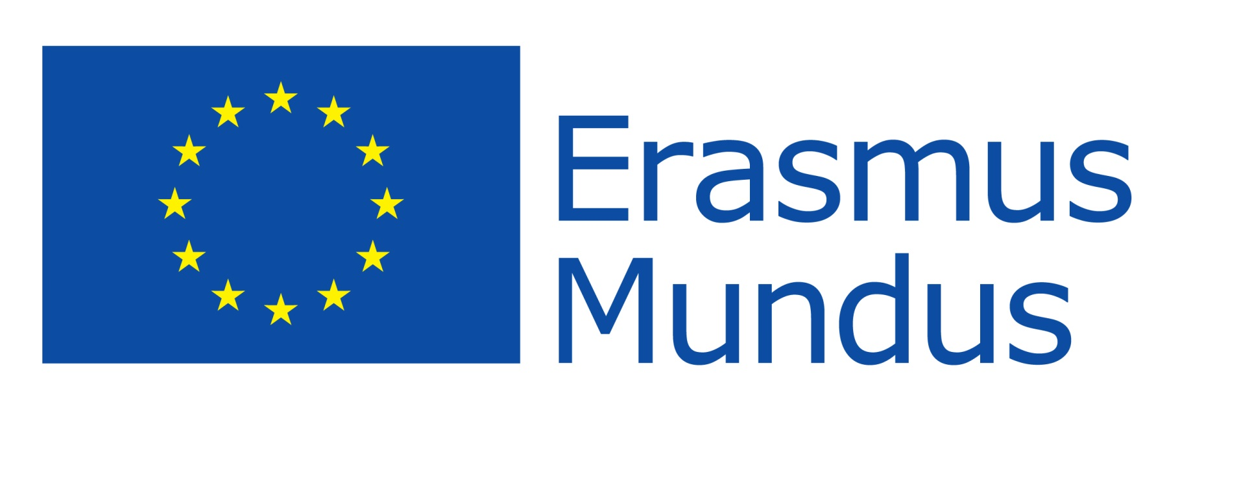

Erasmus Mundus Scholarship APPLICATION FORM
for entry to GLOCAL in September 2020

Please complete this form then sign and upload as a pdf document to your GLOCAL application (standard University of Glasgow Application for Graduate Studies) along with all other supporting documentation*

Apply Now

*Note: The one exemption to this rule is academic references. In addition to accepting references through the online application, the GLOCAL Consortium will also accept references on officially headed institutional paper which are sent directly to the Postgraduate Admissions Team (pgadmissions@glasgow.ac.uk) as scanned email attachments from the referee’s professional email address. All references must be received by the University of Glasgow Admissions Office by the application deadline of 10 January 2020.

- Personal and Contact Information

Title | Click here to enter text.
First name | Click here to enter text.
Family name | Click here to enter text.
Date Birth dd/mm/yyyy | Click here to enter a date.
Country of Birth | Click here to enter text.
City/Town of Birth | Click here to enter text.
Nationality** | Click here to enter text.
**A candidate with multiple nationalities must decide at the application stage under which ONE nationality he/she will apply.
Passport number | Click here to enter text.
Country of Residence*** | Click here to enter text.
*** The contribution to travel and installation costs takes into account ONLY the residence of the scholarship holder at the time of application (regardless of nationality). Please provide the address where you are living as at 10 January 2020
Address:
Street, Number | Click here to enter text.
City, State, Postal Code | Click here to enter text.
Country | Click here to enter text.
Email | Click here to enter text.
Phone number | Click here to enter text.
Mobile number | Click here to enter text.
Do you consider yourself to have a disability? (Please detail where applicable) | Choose an item.  Click here to enter text.

- To be eligible for an Erasmus Mundus Scholarship, an applicant:
- | must not have previously received an Erasmus Mundus Master Course (Action 1) Scholarship
- | must not have applied to more than 3 Erasmus Mundus programmes in the same year
- | must complete this Scholarship Application Form and return it, as instructed, no later than 10 January 2020 to be considered for an Erasmus Mundus Scholarship commencing September 2020
- | must have submitted ALL of the required supporting documents by 10 January 2020. If your offer status is 'holding for documents' then you will NOT be considered for a scholarship unless you submit the required documents by 10 January 2020. The only exception to this is final degree certificates where the applicant has not yet completed their Bachelor degree at the time of application, and English language proficiency certificates.
- | must have addressed all the requirements described on the GLOCAL website.

You must apply as either a “Programme Country” applicant or a “Partner Country” applicant. A list of Programme and Partner countries is available here.
A Programme Country applicant must be;
- a national of a Programme country
or
- a national of a Partner country who has been resident or has carried out their main activity (studies, training or work) for more than a total of 12 months over the last five years in any Programme country/countries. The five-year period is calculated backwards from the submission deadline, i.e. 10 January 2020

All other applicants should apply as a Partner Country applicant.

Please indicate (choose one from each box):
I am applying as a Programme Country applicant

I am applying as a Partner Country applicant

I can self-fund my studies if I do not receive an Erasmus Mundus scholarship

I cannot self-fund my studies if I do not receive an Erasmus Mundus scholarship

Checking the self-funding box will NOT disqualify, nor disadvantage you from being considered for an Erasmus Mundus scholarship.

- Personal Statement

Please be as precise as you can when writing your Supporting Personal Statement. Do not repeat yourself and do not exceed the word limit (1,200 words). You should make sure that you address the following issues in your personal statement:

- You should outline your motivation for choosing the GLOCAL programme (i.e. how it complements and develops your previous studies; how it relates to your potential future career path; how it relates to your personal and academic interests).
- Explain why you think you are a good candidate for the programme given your previous studies and how they relate to the courses offered on the programme in both years.
- If you have significant post-graduation work experience, please explain how those activities relate to the courses offered in the programme and why you are re-entering the academic world.
- Briefly indicate what you might see as being the topic of your Masters thesis (this can change later).
- You should highlight your participation in conferences, internships, non-governmental organisations, summer schools, and other socially sensitive or political activity; as well as any prizes/awards received even if these activities are not specially connected to the area of Global Markets & Local Creativities.

Note: Samples of academic work will not be taken into consideration and should not be submitted.

1,200 words maximum
Click here to enter text.

- Please, select a pathway you are applying for:

Please ensure you have checked the academic entry requirements for your chosen pathway on the website carefully.

Pathway A: “Global History & Creative Industries” (Glasgow, Barcelona, Rotterdam)

Pathway B: “Global Markets & Development” (Glasgow, Barcelona, Göttingen)

Pathway C: “Sustainable Business Development” (Glasgow, Barcelona, Los Andes)

Pathway D: “Global Competition: Industries & Firms” (Glasgow, Barcelona, Kyoto)

Pathway E: “Institutional Change & Creative Industries” (Glasgow, Uppsala, Rotterdam)

Pathway F: “Global Political Economy” (Glasgow, Uppsala, Göttingen)

Pathway G: “Sustainability: Institutions & Management” (Glasgow, Uppsala, Los Andes)

Declaration

- I hereby declare that:
- | I have indicated correctly whether I am applying as a Programme Country or Partner Country applicant.
- | I have not previously received an Erasmus Mundus Master Course (Action 1) Scholarship
- | I have not applied to more than 3 Erasmus Mundus programmes in this year
- | I have addressed all the requirements described on GLOCAL website
- | I have completed sections 1-4 above

Signature................................................................................ Date: ……………………………..

